Executive Report: OLA Ride Operations Analysis
- Retrieve all successful bookings:
SELECT * FROM ola_dataset
WHERE Booking_Status = 'Success';
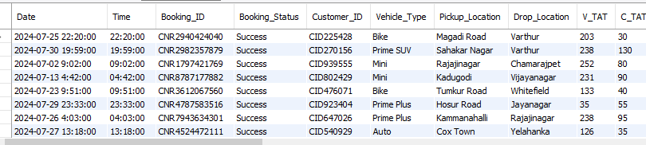
Insight: Measures platform reliability. High success means the system is matching drivers and riders effectively.

- Find the average ride distance for each vehicle type:
SELECT Vehicle_Type, AVG(Ride_Distance) as avg_distance
FROM ola_dataset
GROUP BY Vehicle_Type;
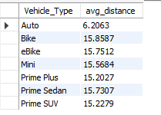
Insight: Helps in fuel & maintenance planning. Tells you which vehicles are best for long vs. short trips.

- Get the total number of cancelled rides by customers:
SELECT COUNT(*)
FROM ola_dataset
where Booking_Status = 'Canceled by Customer';
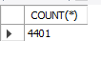
Insight: Highlights user frustration. High numbers suggest long wait times or high prices.

- List the top 5 customers who booked the highest number of rides:
SELECT Customer_ID, count(Booking_ID) as total_rides
FROM ola_dataset
GROUP BY Customer_ID
ORDER BY total_rides DESC
LIMIT 5;
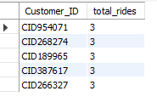
Insight: Identifies VIP users for loyalty rewards and specialized marketing.

- Get the number of rides cancelled by drivers due to personal and car-related issues:
SELECT COUNT(*)
FROM ola_dataset
where Canceled_Rides_by_Driver = 'Personal & Car related issue';
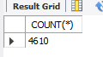
Insight: Flags supply issues. High counts mean drivers need better vehicle support or flexible shifts.

- Find the maximum and minimum driver ratings for Prime Sedan bookings:
SELECT MAX(Driver_Ratings) as max_rating, MIN(Driver_Ratings) as min_rating
FROM ola_dataset
WHERE Vehicle_Type = 'Prime Sedan';
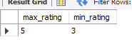
Insight: Monitors luxury service quality. Ensures "Prime" users get the premium experience they pay for.

- Retrieve all rides where payment was made using UPI:
SELECT * from ola_dataset
where Payment_Method = 'UPI';
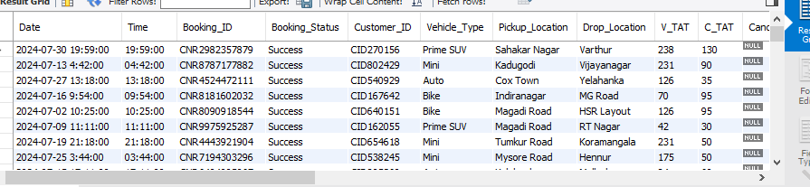
Insight: Tracks digital adoption. Helps reduce cash-handling risks for drivers.

- Find the average customer rating per vehicle type:
SELECT Vehicle_Type, AVG(Customer_Rating) as avg_rating
FROM bookings
GROUP BY Vehicle_Type;
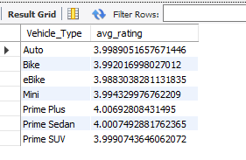
Insight: Pinpoints category problems. Shows if specific vehicle types (like Autos or Bikes) need better standards.

9.Calculate the total booking value of rides completed successfully:
SELECT SUM(Booking_Value)
FROM bookings
WHERE Booking_Status = 'Success';
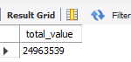
Insight: The bottom line. Shows the actual cash flow from successfully completed trips.

10. List all incomplete rides along with the reason:
SELECT Booking_ID, Incomplete_Rides_Reason
FROM bookings
WHERE Incomplete_Rides = 'Yes';
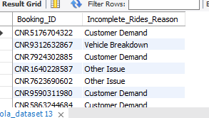
Insight: Root cause problem solving. Tells you exactly why the business is losing money

